**Name:** Vishal Shashikant Salvi.

**Class**: SE Comps

**Batch:** C

**UID: 2019230069**

**Experiment No 7**

**Aim:**

To implement memory management using linux commands.

**Theory:**

Memory management is an essential aspect of every System Administrator to improve the performance of a Linux system. It is always a good practice to monitor swap space usage in Linux to ensure that your system operates relative to its memory demands.

What is Swap space?

Swap space is a restricted amount of physical memory that is allocated for use by the operating system when available memory has been fully utilized. It is memory management that involves swapping sections of memory to and from physical storage.

On most distributions of Linux, it is recommended that you set swap space when installing the operating system. The amount of swap space you can set for your Linux system may depend on the architecture and kernel version.

1. Using the swapon Command

This command helps you to specify the devices on which paging and swapping will be done and we shall look at few important options.

To view all devices marked as swap in the /etc/fstab file you can use the **--all** option. Though devices that are already working as swap space are skipped.

# swapon --all

If you want to view a summary of swap space usage by device, use the **--summary** option as follows.

**# swapon --summary**

Filename Type Size Used Priority

/dev/sda10 partition 8282108 0 -1

Use **--help** option to view help information or open the manpage for more usage options.

#### 2. Using /proc/swaps which is equivalent to swapon

The **/proc** filesystem is a very special virtual filesystem in Linux. It is also referred to as a process information pseudo-file system.

It actually does not contain ‘real’ files but runtime system information, for example system memory, devices mounted, hardware configuration and many more. Therefore you can also refer to it as a control and information base for the kernel.

To check swap usage information, you can view the **/proc/swaps** file using the [cat utility](https://www.tecmint.com/13-basic-cat-command-examples-in-linux/).

**# cat /proc/swaps**

Filename Type Size Used Priority

/dev/sda10 partition 8282108 0 -1

#### 3. Using ‘free’ Command

The **free** command is used to display the amount of free and used system memory. Using the free command with **-h** option, which displays output in a human readable format.

**# free -h**

total used free shared buffers cached

Mem: 7.7G 4.7G 3.0G 408M 182M 1.8G

-/+ buffers/cache: 2.7G 5.0G

Swap: 7.9G 0B 7.9G

From the output above, you can see that the last line provides information about the system swap space.

#### 4. Using top Command

The top command displays processor activity of your Linux system, tasks managed by kernel in real-time.

# top

[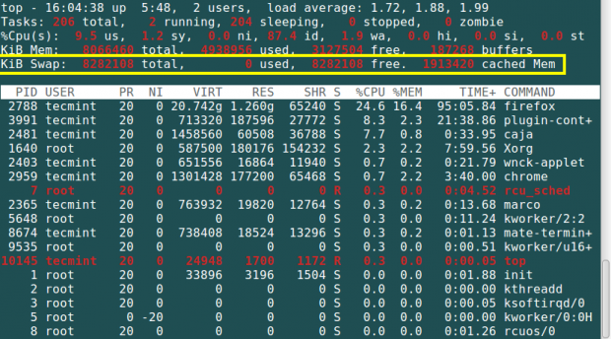](https://www.tecmint.com/wp-content/uploads/2015/10/Check-Swap-Space-Using-Top-Command.png)

5. Using atop Command

The atop command is a system monitor that reports about activities of various processes. But importantly it also shows information about free and used memory space.

# atop

[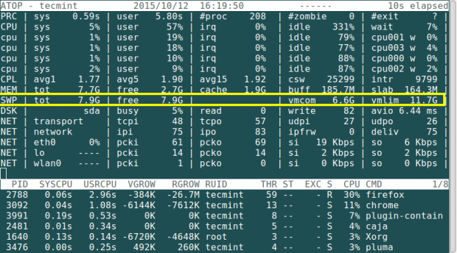](https://www.tecmint.com/wp-content/uploads/2015/10/Atop-Check-Swap-Usage.png)

6. Using htop Command

The htop command is used to view processes in an interactive mode and also displays information about memory usage.

# htop

[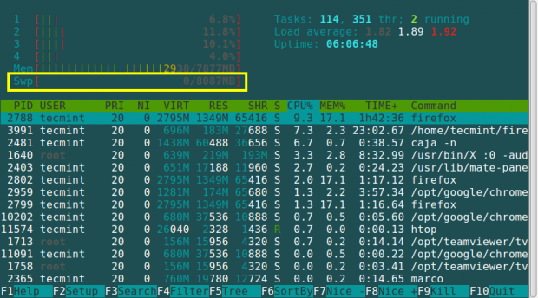](https://www.tecmint.com/wp-content/uploads/2015/10/Htop-Check-Swap-Usage.png)

7. Using the Glances Command

This is a cross-platform system monitoring tool that displays information about running processes, cpu load, storage space usage, memory usage, swap space usage and many more.

# glances

[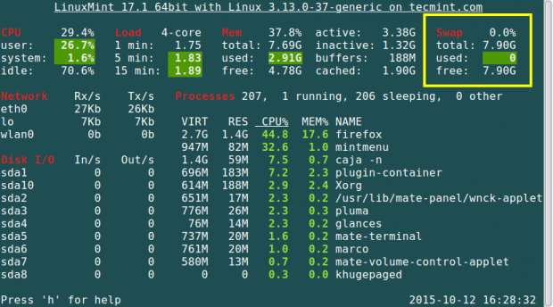](https://www.tecmint.com/wp-content/uploads/2015/10/Glances-Check-Swap-usage.png)

8. Using the vmstat Command

This command is used to display information about virtual memory statistics. To install vmstat on your Linux system, you can read the article below and see more usage examples:

[Linux Performance Monitoring with Vmstat](https://www.tecmint.com/linux-performance-monitoring-with-vmstat-and-iostat-commands/https:/www.tecmint.com/linux-performance-monitoring-with-vmstat-and-iostat-commands/)

# vmstat

[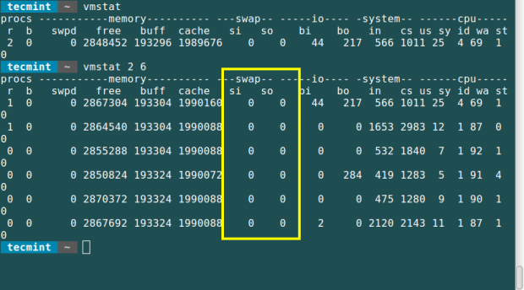](https://www.tecmint.com/wp-content/uploads/2015/10/VmStat-Check-Swap-Usage.png)

**Commands:**

**Top**

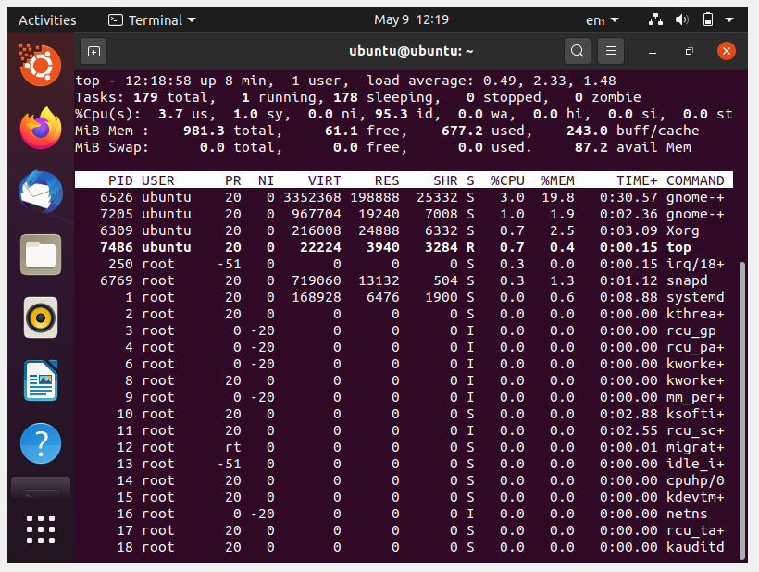

**Free**

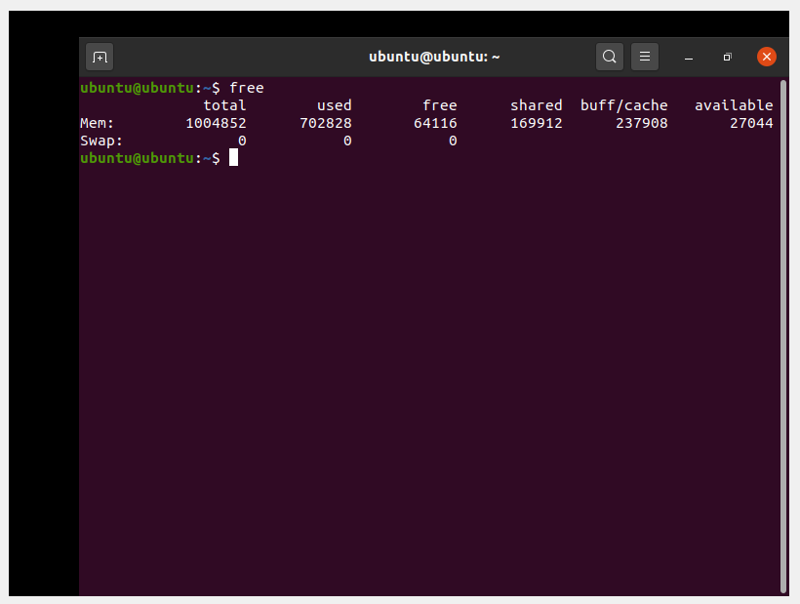

**Vmstat**

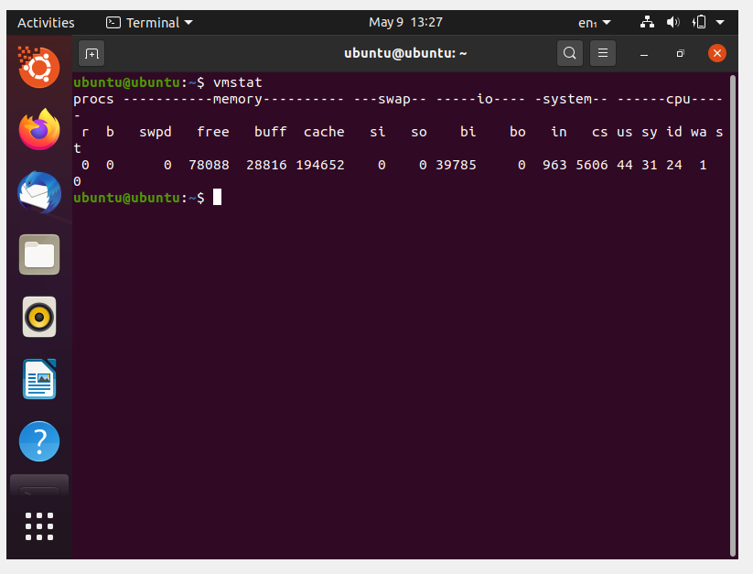

**Vmstat -a**

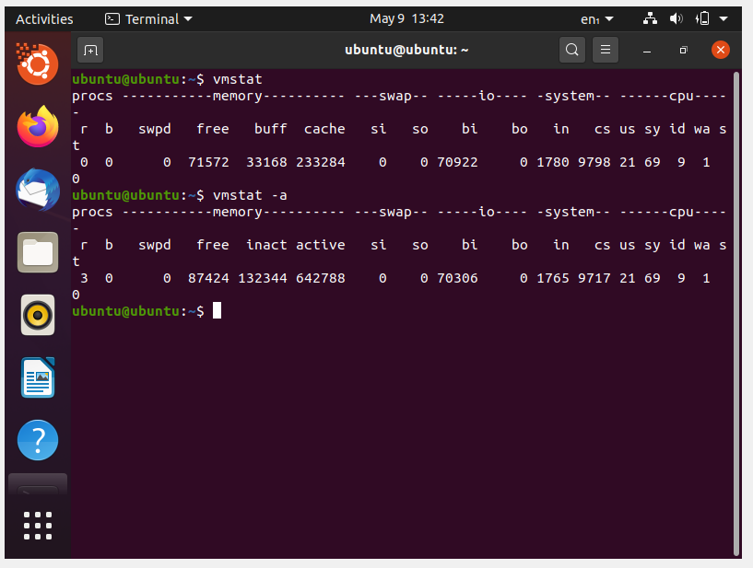

**Vmstat -d**

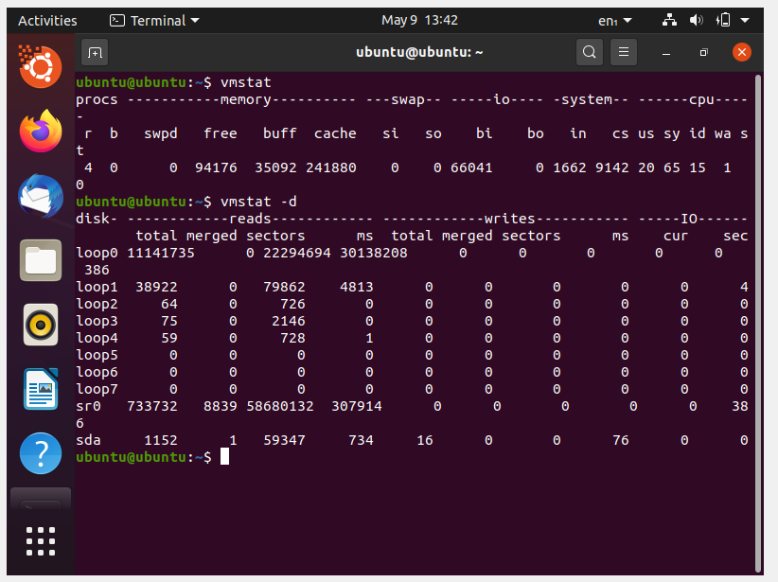

**Vmstat -D**

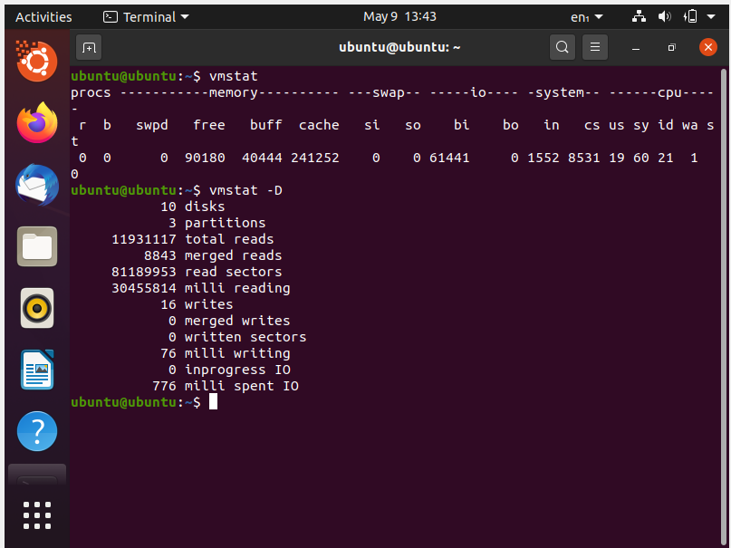**Free/free -h**

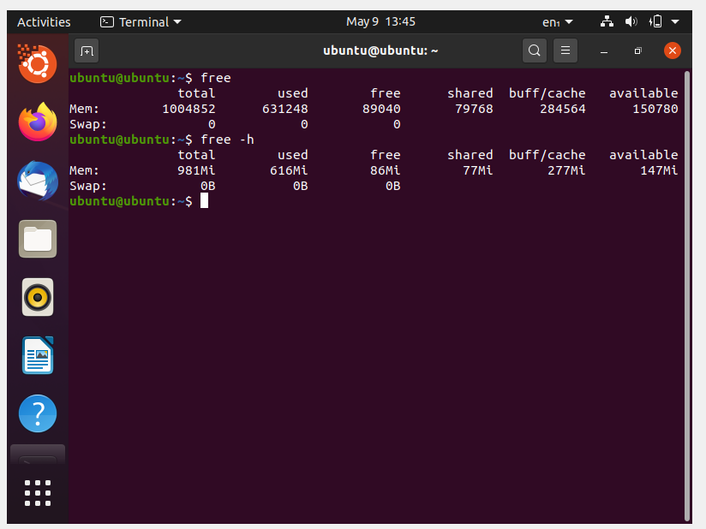

**Cat /proc/meminfo**

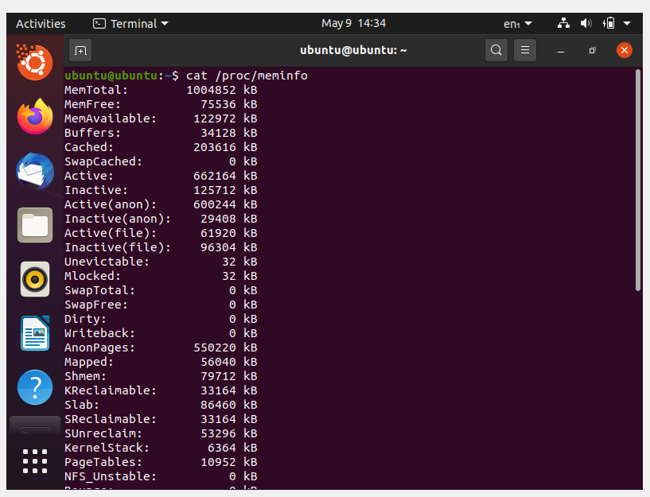

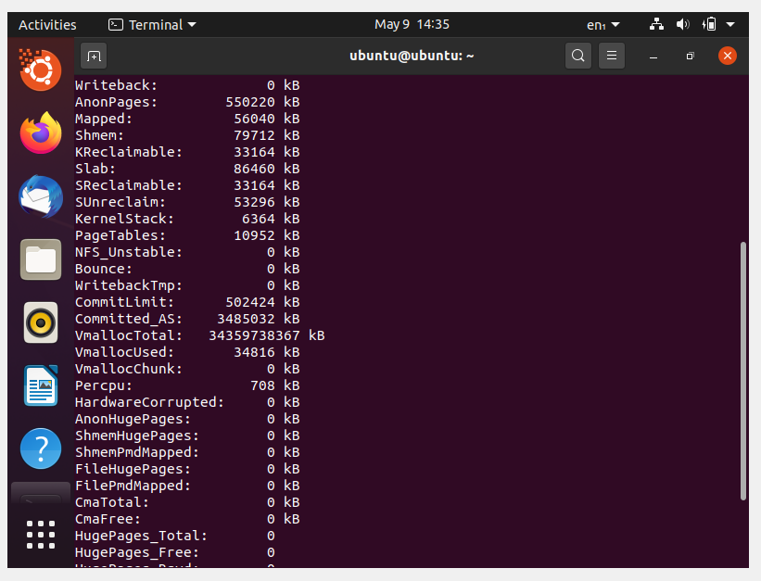

**Cat /proc/swaps**

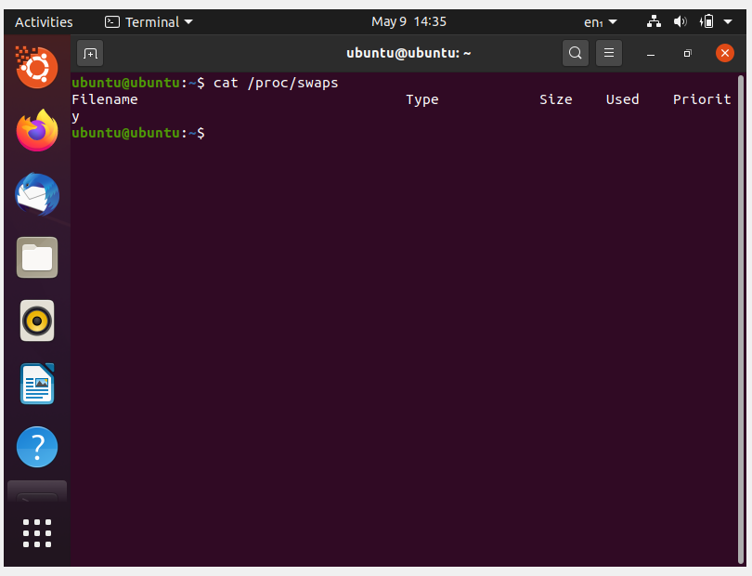

**Conclusion:**

Thus, From above experiments, I learn about various linux commands related to memory management.